Assignment Momentum
Name: _______________________________

1. A steel ball of mass 0.6 kg moving with a velocity of 2.3 m/s [N] collides with a second ball of mass 0.4 kg, initially at rest. The collision is a glancing one, otherwise where is the challenge. The 0.6 kg ball moves off with a velocity of 1.7 m/s [E 35.0°N] after the collision. Determine the velocity and direction of the second ball after the collision. The entire scenario takes place on a frictionless surface.

2. Two dancers, from Dancing with the Stars™, undergo a collision, in which their arms are intertwined and they had a common velocity of 1.1 m/s [E 6.8°S]. Before the collision, the 69 kg dancer had a velocity of 1.0 m/s [E 14°N], while the other dancer had a velocity of 1.31 m/s [E2°S]. What is the mass of the second dancer? The dance floor is smooth and frictionless. The crowd cheered for everyone, even those that collide.

3. A pumpkin of mass 3.30 kg was at rest on a smooth, frictionless step, when it suddenly exploded into exactly three pieces in the same horizontal plane. A 0.50 kg piece flew off horizontally to the north at 3.2 m/s. A 1.4 kg piece flew off horizontally at 4.1 m/s [SW]. What was the speed, direction and mass of the third piece?

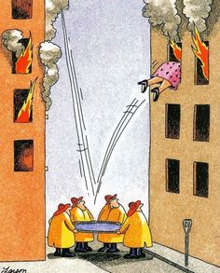
[5 marks each]

