Assignment Work and Energy

- Matt pushes at an angle of 35˚ to the horizontal on a shopping cart full of physics related memorabilia with 56.78 N of force, moving it a distance of 25.00 m horizontally.
- Find the work that Matt does on the cart.
- If there is a frictional resistance of 17 N on the cart wheels with the floor what negative work is done against Matt’s motion?
- What is the overall work done on the cart?
- If Matt does this overall work in a time of 36.7 s what is his power rating? How many horsepower is this equivalent too?

- Mike lifts his spare anvil of mass 89 kg from the floor to a height of 1.3 m onto a bench. How much gravitational energy does this create for the anvil?

- Kayla has always wanted to try cliff diving. So she runs off a cliff with a speed of 4 m/s and dives into the water 10.5 m below. Kayla has a mass of 55 kg.
- What gravitational energy will Kayla have at the top of the cliff?
- What kinetic energy will Kayla have at the top of the cliff?
- What total energy does Kayla have during the trip?

- Owen pulls on Brad with 267 N of force pulling him 5 m. What work does Owen do on Brad? If the Brad resists with a force of 200 N what negative work does Brad do back on Owen? What is the overall work done?

- Mackenzie takes a duck of 1.4 kg cradled in her arms (who wouldn’t want to hug a duck) for a walk of length 50.0 m (horizontally). How much work has Mackenzie done on the duck? Explain.

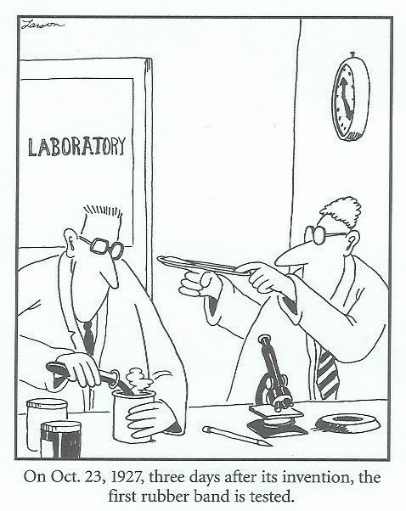
- Carson slides down a 5.78 m fireman’s pole that has no frictional resistance with his hands. If Carson has a mass of 65 kg, find
- The total energy Carson has at the top of the pole if he starts from rest.
- The total energy Carson has at the bottom of the pole.
- The speed Carson has at the bottom of the pole just before he hits the ground.

