Circular Reasoning Assignment

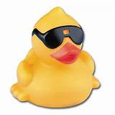
- A small plastic duck of mass 25 g is placed 20 cm from the centre of a rotating turntable. The duck does not slip as the turntable rotates at a constant angular speed of 40 rpm.
- What is the magnitude of the duck’s linear velocity?
- What is the magnitude of the duck’s acceleration?
- If the coefficient of static friction between the duck and the surface is 0.65, what would be the greatest rotational speed the turntable could have in rpm and still have the duck stay in place?

- A 400 m radius curve is banked at 12º.
- What is the critical velocity of the car travelling through the curve?
- If the car were to travel at this same speed through a regular flat curve of the same radius, how large would the coefficient of friction need to be to maintain the car’s contact with the road?

- A 250 g pendulum bob is initially constrained at a 53º angle by two strings as shown.
- What is the initial tension in the diagonal string?
- What is the initial tension in the horizontal string?
- What the horizontal string is cut the pendulum begins to swing. As the pendulum bob passes through the lowest point, what will be its speed?
- At the lowest point what is the tension in the string?

- A 100 kg car is released from rest on an incline of height H. At the base of the rap it encounters a loop-the-loop of radius 80 m.
- What is the value of H if the car just barely remains in contact with the track at the top of the loop-the-loop?
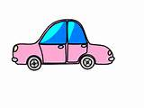
- How far will the car travel along the exit track if the coefficient of friction on the exit track is 0.2 and no brakes are applied?

