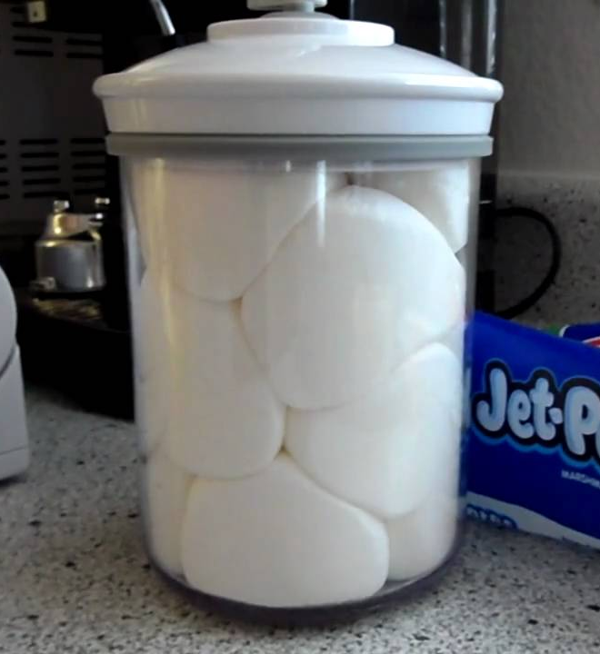
Ballooning Marshmallows
How to Balloon a Marshmallow
Take a large marshmallow place in to a container from which the air can be evacuated. A marinating tray, vacuum table or any such device works best. As the air is evacuated a vacuum is created which causes the air trapped in the marshmallows to expand. The marshmallow grows. If the air is suddenly let back into the container (vacuum destroyed), the air in the marshmallows is compressed and the marshmallow shrinks and shrivels up.

Theory
A vacuum is a volume of space in which there is no matter or in which the pressure is so low that any particles in the space do not affect any processes being carried on there. It is a condition well below normal atmospheric pressure (101.3 kPa). Outer space would be considered a vacuum as there are very few particles and low pressure.
Pressure (P) is the force applied perpendicular to the surface of an object per unit area over which that force is distributed. Pressure may also be expressed in terms of standard atmospheric pressure (101.3 kPa) or sometimes called air pressure. Pressure always travels from areas of high pressure to low pressure.
How Ballooning Marshmallows Works?
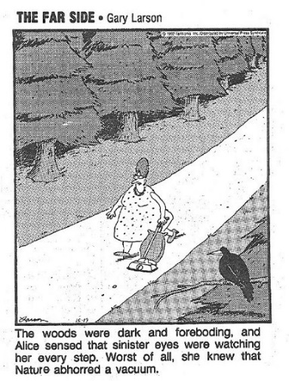
As the pressure is lowered in the vacuum chamber by removing the particles of air, the air trapped inside the marshmallow will expand. The air in the marshmallow is at a higher pressure than the vacuum chamber. Since pressure always moves from high to low, the marshmallow expands (or the air in the marshmallow expands). If air is suddenly let back into the container the pressure imbalance no longer exists and the air in the marshmallow will go back to normal size. However, some of the air has escaped the marshmallow. So the marshmallow will shrivel up and be smaller in size then before as it no longer has the original air to maintain its structural integrity.
References
https://en.wikipedia.org/wiki/Pressure
https://www.britannica.com/science/vacuum-physics
https://www.youtube.com/watch?v=l1XuojNXtZg
http://www.eoht.info/photo/12650502/Nature+Abhors+a+Vacuum+%28the+Far+Side%29

