**PHYSICS 4U1 Final Project Due Date: January _____, 2019 ­­­**

1. Create a 1 page (8.5 x 11) “Help Sheet” that can be used during your exam. It should include all formulas, constants, helpful hints and definitions that you feel you will need for the exam. You can write as small or large as you want and can write on all six sides of the 1 page. It can be typed but should not be a photocopy of another sheet. (Make your own). This portion must be signed off on before the exam. /20

2. For many years a great debate has been waged regarding the nature of light (wave or particle). Evidence describing Reflection, Refraction, Partial Reflection/Partial Refraction, Diffraction, Interference and Rectilinear Propagation has been observed for both sides of the debate. Discuss (possibly in a chart) the evidence for and against each type of evidence and the conclusion reached in the debate. /10

3. Complete four of the following seven problems. Include all work, formulas and concluding statements. /5 each

a. Miss Takken is cruising along at 4 m/s (in her cool Fizz X car) when a physics student

(who did not hand in their lab) passes her in a pickup truck going at a speed of 13 m/s.

If Miss Takken can accelerate at 2.5 m/s2

a. How long will it take Miss Takken to catch this student?

b. At what distance from the initial pass will she catch them?

c. How fast will Miss Takken be going when she catches the student?

b. Miss Takken builds the following machine. What is the acceleration of the system illustrated below? Assume that it starts from rest. How long for the 5.0 kg mass to reach the top of the ramp?

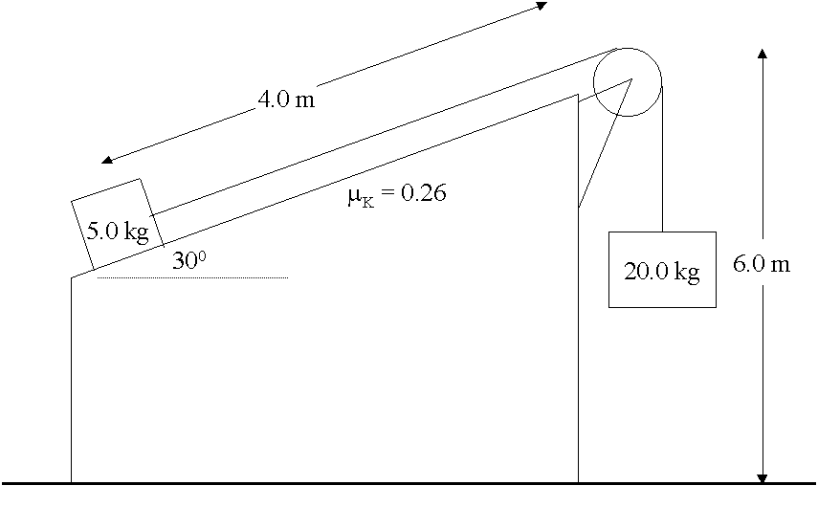

c. Miss Takken wants to pass a very important 10 kg assignment up to a student who is at a window above the ground. Miss Takken slides the assignment from rest, up a 10 m, 10° ramp with a coefficient of friction of µ = 0.24. What applied force must Miss Takken impart to the assignment if she wants it to reach the student’s hands in 4.5 s?

d. Miss Takken launches a satellite of mass 700 kg is launched from the Earth’s surface to an orbit of mean altitude of 950 km. Find

a. Its kinetic energy in orbit.

b. Its orbital velocity

c. Its binding energy.

d. How much speed does the satellite have to gain to escape the Earth from this orbit?

e. In a warm-up for the Olympics free skating competition, Miss Takken, mass 60 kg, moving at 5 m/s and looking at her coach, collides with Mr. Currie, mass 65 kg, who is smiling at a photographer. Mr. Lacey is also on the ice and notes that the skaters approached at right angles and after the collision hang on to each other, moving off as a single body at an angle of 37° down from Miss Takken’s original direction. Find Mr. Currie’s original speed. (Answer in m/s).

f. What is the electric field intensity at the centre of the square shown in the figure below. Assume that q = 2.1 x 10-8 C and d = 5.0 cm (side length).

+3 q -2 q



P

- 3q +4q

g. Miss Takken swings a 2 kg plastic duck on a string in a circle of a conical pendulum. The object is  
attached to a 50 cm long string and tracks out a horizontal circle of 35 cm radius.

a. What is the measure of the angle of the conical pendulum?

b. What is the tension in the rope?

c. How fast is the mass travelling as it swings?

d. How many revolutions does the object complete per second?

**Note: These are not the only possible types of questions that could be asked on the exam but just a select few.**