Final Project SPH 3U1
10 % of Final Mark
Due Date: TBA

Requirements: 3-4 page report.

Research Project
~ Take an everyday concept and explore the concept using physics or research a famous physicist and their contribution to the field of physics.
~ Write a 3-4 page report describing your research on your chosen topic. Include a works cited.
~ Graphics can be included but must enhance your essay and be explained and properly referenced. They should not just take up space.

Examples: The Physics of Skydiving
Optics and Lenses in Relation to Optometry
The Physics of Catapults and Weaponary
The Physics of Sound and Echo Location
The Physics of Hydraulics in Relation to Industry
The Physics behind Billards
Galileo, Kepler, Planck, Schroedinger, Doppler, Cavendish, Maxwell, Lenz, Etc.

A project proposal is due ____________ listing the option and topic chosen as well as possible resources and a time line you have set out for yourself to complete this project.

Projects will be due ____________________________. No excuses for late assignments will be accepted.

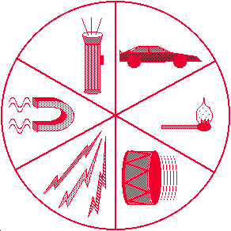
TO DO A PROJECT!

Note: No one is allowed to do a report on Newton or Einstein!
Rubric Physics Project

Criteria | Level 1 | Level 2 | Level 3 | Level 4
Knowledge and Understanding  Demonstrates knowledge of chosen physical concept | - displays limited knowledge of chosen concept. | -displays some knowledge of chosen concept. | -displays considerable knowledge of chosen concept. | -displays a thorough understanding of chosen concept.
Application  Demonstrates understanding of physics behind concept chosen. | - report explains the person and/or concept with proper language and physical symbols with limited success. | - report explains the person and/or concept with proper language and physical symbols with some success. | - report explains the person and/or concept with proper language and physical symbols and equations with considerable success. | - report explains the person and/or concept with proper language and physical symbols and equations with a high degree of success.
Communication  Degree of clarity and organization in report | - report is incomplete as they do not meet all scenarios of the physical concept chosen and is worded with limited clarity and organization. | -report is complete but does not meet all scenarios of the physical concept chosen and is worded with some clarity and organization. | -report is complete, meeting most scenarios of the physical concept chosen and is worded with considerable clarity and organization. | -report is complete, meeting all scenarios of the physical concept chosen and is worded with a high degree of clarity and organization.

In addition marks for neatness, grammar, spelling, organization, works cited and being on time will be awarded out of /10

