SPH 3U Lab # 3: Gravity and A Pendulum
Name: _____________________________ Date: ____________________________________
Occasionally, it’s a good idea to check some of the fundamental laws of physics for validity. You never know if those physicists made a mistake or the nature of the universe recently took a turn for the worse. In this lab you will test the validity of the value of g and determine what affects this value using a simple gravity pendulum.
Problem: What variables affect the acceleration due to gravity?
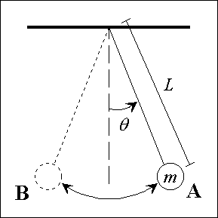
Materials: meter stick, string, washers or weights, scale, timer
L = length of pendulum when hanging freely.
Θ = amplitude of the swing
A B A is one complete swing (there and back again)

Procedure:
- Set up a pendulum hanging from the ceiling that is approximately 1.00 m long with mass suspended. Measure the length exactly and record it along with the mass.
- Set the pendulum swinging and time 20 complete cycles. Record the time. Repeat twice.
- Change the length to approximately 0.75 m long with the same mass. Measure the length exactly and record. Repeat step 2.
- Change the length to approximately 0.50 m long with the same mass. Measure the length exactly and record. Repeat step 2.
- Keeping the length at 0.5 m change the mass. Repeat step 2. Repeat this for 3 different masses in total.
- Keeping the length at 0.5 m and mass consistent change the amplitude of the swing. Measure the amplitude θ with a protractor. Repeat step 2. Repeat for three different amplitudes.

Observations:
- Record all your information for length, mass and amplitude in three different tables. An example is shown below. Recall that you must include sample calculations for all your calculations no matter how minor. You will need three tables with nine values each.

Trial | Mass (kg) | Length (m) L | Amplitude (^{O}) A | Time for 20 cycles (s) | Time for 1 cycle (s) T | g (m/s²) | % Error

- To calculate g use the formula, $g= \frac{4π^{2}L}{T^{2}}$.
- Using the formula for % Error compare this value to 9.8 m/s² which is the accepted value for acceleration due to gravity on earth.

Discussion:
- According to your data what is the best result for measuring g?
- Does changing the length change your results for g? Recall anything within ±10 % is considered experimentally valid.
- Does changing the mass change your results for g? Does changing the amplitude change your results for g?
- Explain thoroughly all instances where experimental error is introduced into the experiment. Recall do not discuss human error, only systematic and random error that comes from measurements.

